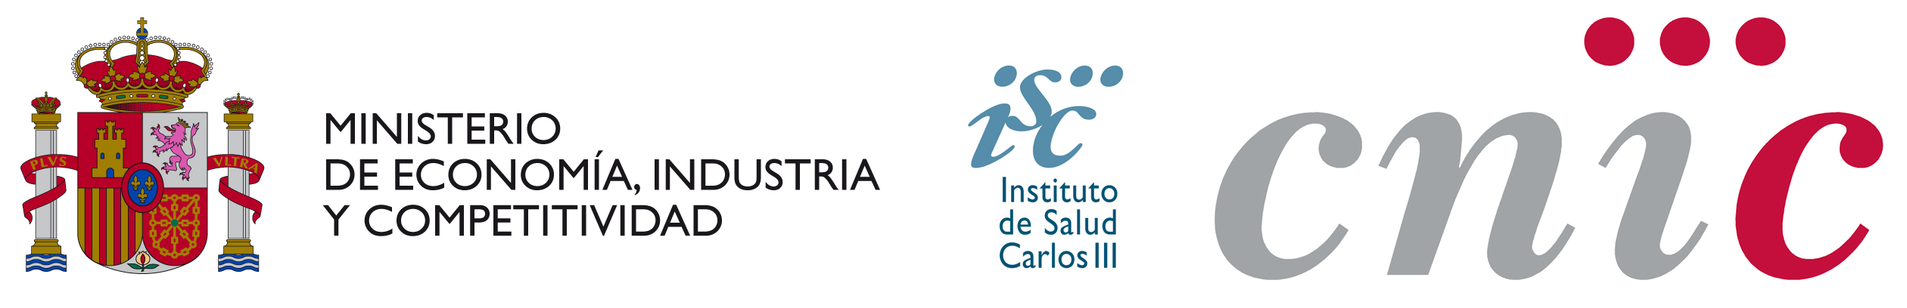


Eleventh Call for Proposals

DOCUMENT OF ACCEPTANCE

General Information
Name | Middle name(s)
Surname | NIF/NIE / Passpot

Laboratory where the candidate has been accepted
Scientist-supervisor | Research Line

Dates of training period
Starting date | Finishing date

Signature of supervisor  Date: | Signature of candidate  Date:

Complete this form and send it to the e-mail address: cicerone@cnic.es

In accordance with the provisions of article 5 of Organic Law 15/1999 of 13 December on the Protection of Personal Data, we inform you that personal data collected as a consequence of the current session will be incorporated into an automated file called HR registered in the Spanish Agency of Data Protection under the ownership of the Foundation National Center for Cardiovascular Research CARLOS III, its purpose being to process your registration and participation in this notification/announcement, as well as to track your career and professional training by sending different corporative material of the Centre to the address you provided. There is no expectation of the transfer of personal data to any third party outside to the Center. Also, you may exercise your right to object to the treatment described, as well as the rights of access, rectification and deletion of information provided to the Centre by contacting the following address: National Center for Cardiovascular Research Carlos III (CNIC), Calle Melchor Fernández 3, (28029) Madrid.
The processing of your personal information as described in the previous section is necessary for the Centre to manage your registration in this training event, without which, the inscription will not be possible.

